**Contents**

1. **Introduction**
   1. Objective of the Project .................................................................................................1
   2. Brief Description of the Project .....................................................................................2
   3. Technology Used .........................................................................................................2
      1. Hardware Requirement ......................................................................................2
      2. Software Requirement .......................................................................................3
2. **Design Description**
   1. Flow Chart ....................................................................................................................3
   2. Data Flow Diagram (DFDs) ..........................................................................................3
      1. Level 0 Data Flow Diagram ...............................................................................3
      2. Level 1 Data Flow Diagram ...............................................................................4
   3. Entity Relationship Diagram (E-R Diagram) ...............................................................4
3. **Project Description**

**3.1** Dataset ..........................................................................................................................5  
**3.2** Data Processing ............................................................................................................5  
**3.3** Database .......................................................................................................................7  
**3.4** Table Descriptions .......................................................................................................7  
**3.5** File/Database Design .....................................................................................................8

1. **Input/Output Form Design**

**4.1** Input Design ..................................................................................................................8  
**4.2** Output Design ................................................................................................................9

1. **Testing & Tools Used**

**5.1** Testing Techniques .....................................................................................................10  
**5.2** Tools Used ...................................................................................................................12

1. **Implementation & Maintenance**

**6.1** Model Training ............................................................................................................13  
**6.2** API Integration ............................................................................................................13  
**6.3** User Interface (Flutter) ................................................................................................13  
**6.4** Database Integration ....................................................................................................13  
**6.5** System Optimization & Maintenance ..........................................................................13

1. **Conclusion and Future Work**

**7.1** Summary of Achievements .........................................................................................14  
**7.2** Future Work………......................................................................................................14

1. **Outcome**

**8.1** Key Achievements ......................................................................................................15  
**8.2** Real-Time Deployment Potential .................................................................................15

**9. Bibliography** .......................................................................................................................16

**1. Introduction**

This project, **Intelligent Retinal Imaging System (IRIS)**, is an **AI-driven ocular diagnostics application** designed to detect and classify eye diseases using smartphone-captured images. With the increasing prevalence of eye disorders such as conjunctivitis, **early and accurate diagnosis** is crucial. Traditional diagnostic methods rely heavily on manual examination, which can be time-consuming and prone to error. The IRIS project aims to bridge this gap by leveraging **deep learning** to provide an efficient and accessible solution for **early detection and classification** of ocular conditions.

In parallel, the project also explores a **Few-Shot Learning (FSL)** paradigm using **Prototypical Networks** for scenarios where eye image data is scarce. Additionally, **Local Binary Patterns (LBP)** are employed in some experiments to enhance texture-based feature extraction, further improving disease detection.

By integrating **Vision Transformers (ViTs)** and **Convolutional Neural Networks (CNNs)**, the system will process images in real-time, enhancing **diagnostic accuracy and reliability**. The approach includes **image pre-processing techniques** such as noise reduction, contrast enhancement, and edge detection to improve image clarity and feature extraction. The solution is being designed to function efficiently on **mobile devices** using **TensorFlow Lite (TFLite)** for on-device processing, or through **cloud-based deployment** for scalable performance. This multi-faceted approach ensures the system is adaptable across various environments and use cases, making it valuable for healthcare professionals and individuals seeking early diagnosis.

The primary goal of IRIS is to develop an **AI-driven mobile solution** that empowers users with an early screening tool for ocular diseases. By integrating deep learning techniques, the project aims to significantly **reduce dependency on manual diagnosis**, improving accessibility to timely and accurate eye care solutions.

**1.1. Objective of the project**

This project focuses on developing a **machine learning-based ocular disease classification system**, capable of detecting conjunctivitis and other eye conditions from smartphone images. By utilizing **deep learning models** and **computer vision techniques**, the system will accurately process eye images and provide **instant diagnostic results**. The solution is designed for real-world deployment, ensuring efficient disease identification and **real-time classification**.

* **Objective 1**: Develop a **robust AI model** that detects and classifies eye diseases using smartphone images, integrating seamlessly with **mobile and cloud platforms** (including **Flutter**-based applications) for real-time processing.
* **Objective 2**: Implement **image enhancement and segmentation techniques** to preprocess eye images, ensuring accurate disease detection across varying lighting and environmental conditions.
* **Objective 3**: Optimize and deploy the system using **TensorFlow Lite (TFLite) for on-device classification** or **cloud-based AI services** for scalable processing.

**1.2. Brief description of the project**

The **IRIS system** integrates **deep learning** and **computer vision** to analyze eye images and diagnose diseases efficiently. The **Flutter** application serves as the primary user interface, allowing users to capture images with their smartphone camera or select images from the gallery, and then forwarding them for AI-based classification. The core workflow consists of the following stages:

1. **Image Acquisition & Preprocessing**
   * The system captures an image of the eye using a smartphone camera through the **Flutter** app interface.
   * Preprocessing techniques such as **grayscale conversion**, **contrast enhancement**, and **noise reduction** improve image quality.
2. **Feature Extraction & Segmentation**
   * The image undergoes **segmentation** to isolate key regions of interest.
   * **Edge detection** and **morphological transformations** highlight disease patterns.
3. **Classification & Diagnosis**
   * A **deep learning-based model** (ViTs or CNNs) processes the image for disease classification.
   * The AI model predicts whether the eye shows signs of disease, such as conjunctivitis.
   * **Results are displayed on the Flutter-based mobile interface**, along with a confidence score.

This system is designed to be **scalable and deployable** in healthcare settings, providing an **accessible AI-based solution** for early ocular disease detection. The dataset for training includes **diverse eye images**, ensuring generalizability across various conditions.

**1.3. Technology Used**

**1.3.1. Hardware Requirements**

* **Processor**: Intel Core i5/i7 or equivalent (for model training)
* **RAM**: Minimum 8GB for efficient execution
* **GPU**: NVIDIA CUDA-enabled GPU (e.g., RTX 3060) for deep learning acceleration
* **Storage**: At least 20GB of free space for dataset storage and model training

**1.3.2. Software Requirements**

* **Programming Language**: Python for model development; Dart for Flutter front-end
* **Libraries/Frameworks**: OpenCV, TensorFlow/Keras, NumPy, Matplotlib, TensorFlow Lite (TFLite)
* **Development Environment**: Google Colab, Jupyter Notebook for AI; Android Studio or Visual Studio Code for Flutter
* **Database Management**: Firebase, MySQL
* **Cloud Computing**: Google Cloud / AWS for scalable model deployment
* **Flutter**: Cross-platform UI framework for Android, iOS, Web, and Desktop

**2. Design Description**

**2.1. Flow Chart**

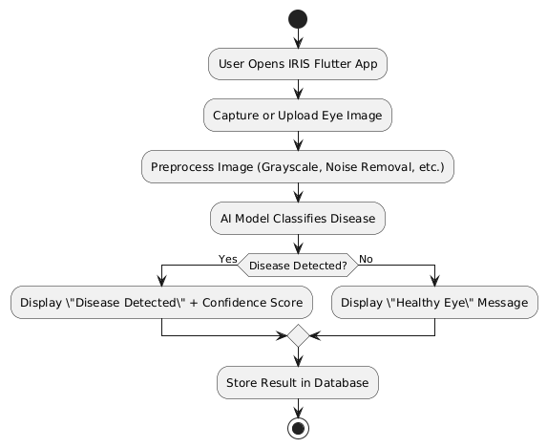

Figure 1 IRIS Flowchart

**2.2. Data Flow Diagrams (DFDs)**

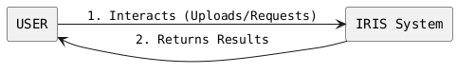

Figure 2 Data Flow Diagram (Level 0)

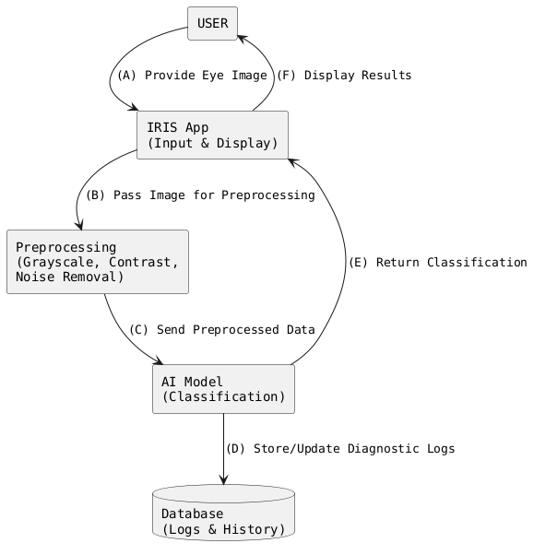

Figure 3 Data Flow Diagram (Level 1)

**2.3. Entity Relationship Diagram (ER-Diagram)**

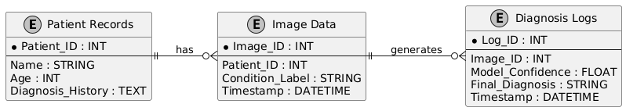

Figure 4 Entity-Relationship (ER) Diagram

1. **Project Description**

**3.1. Dataset**

The **IRIS Dataset** is used to train and evaluate the AI-driven ocular diagnostic system. It contains images of human eyes labeled with disease conditions, enabling the deep learning model to classify images as either healthy or indicative of an eye disease such as conjunctivitis. The dataset includes diverse image samples to ensure **model generalization** across different lighting conditions, angles, and eye features. In addition to the primary dataset of 50,000 labeled eye images, a smaller set of smartphone-captured images was curated from online sources for a **Few-Shot Learning** experiment.

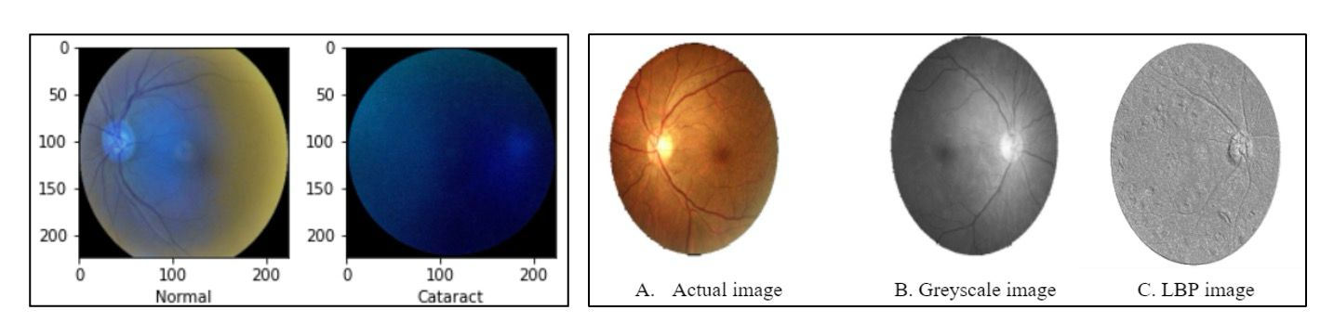

Figure 5 Samples from the ODIR-5K Dataset

**Key Details about the Dataset**:

* **Image Format**: JPEG, PNG, and other common image formats.
* **Image Resolution**: The dataset includes images of varying resolutions, from low to high resolution.
* **Disease Categories**: Various ocular conditions such as conjunctivitis, cataracts, and normal eye conditions.
* **Annotations**: Each image is annotated with disease classification labels and bounding box coordinates (if applicable).
* **Size of Dataset**: 50,000 labeled eye images, including metadata like patient age, symptoms, and severity levels.

This dataset allows for robust training of the model by incorporating a wide variety of eye disease conditions and ensuring accuracy in classification.

**3.2. Data Processing**

The data processing pipeline plays a crucial role in preparing the dataset for model training. Below are the steps involved:

1. **Image Preprocessing**
   * **Grayscale Conversion**: Images are converted to grayscale to reduce computational complexity.
   * **Noise Removal**: Filters are applied to remove noise that may affect detection accuracy.
   * **Image Resizing**: All images are resized to a uniform resolution to ensure consistent input into the model. For the **Prototypical Networks** pipeline, preprocessed images are resized (e.g., 224x224) and normalized. We rely on transfer learning backbones (VGG19, ResNet50, DenseNet121) for feature extraction.
   * **Local Binary Pattern (LBP)**: Local Binary Pattern (LBP) is a texture-based descriptor used to highlight fine-grained patterns in fundus images. This helps improve disease differentiation by capturing subtle retinal structures.

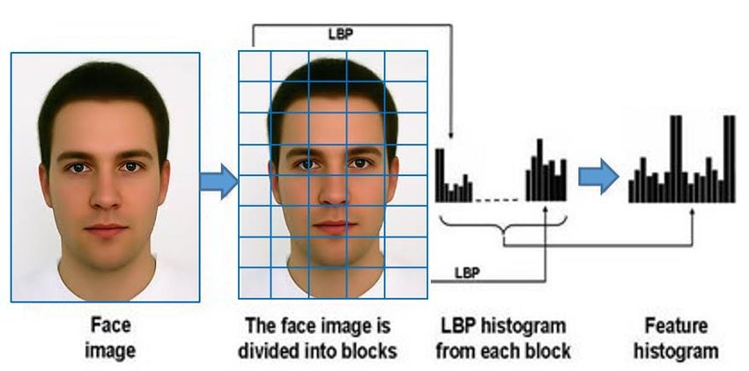

Figure 6 Local Binary Pattern (LBP)

1. **Feature Extraction**
   * **Segmentation**: The eye region is isolated using contour and edge detection.
   * **Contrast Enhancement**: Histogram equalization improves visibility of key features such as blood vessels and corneal reflections.
2. **Disease Classification**
   * **Deep Learning Model**: A trained model (CNN or Vision Transformer) analyzes the image and classifies it into disease categories.
   * **Confidence Score Calculation**: The model assigns a probability score indicating its confidence in the diagnosis.
3. **Model Training**
   * **Data Augmentation**: Techniques like flipping, rotation, and brightness adjustment improve model robustness.
   * **Transfer Learning**: Pre-trained models fine-tuned on medical image datasets speed up training and enhance accuracy.
4. **Integration with Database**
   * Detected conditions and classifications are stored in a structured database for later retrieval and analysis.

**3.3. Database**

The IRIS system utilizes a **relational database** to store and manage diagnostic data efficiently. This database ensures that diagnostic records can be accessed quickly, allowing seamless integration between the **AI model** and the **Flutter** application’s front-end.

The database consists of the following key tables:

* **Patient Records Table**: Stores patient details, including age, gender, and previous diagnoses.
* **Image Data Table**: Stores eye images linked to patient IDs and classification results.
* **Diagnosis Logs Table**: Maintains records of past AI predictions, including model confidence scores and timestamps.

These tables are designed to be **scalable**, allowing easy integration with telemedicine platforms and future AI enhancements.

**3.4. Table Descriptions**

1. **Patient Records Table**
   * **Patient_ID**: Unique identifier for each patient.
   * **Name**: Patient’s name (if applicable for research purposes).
   * **Age**: Patient’s age.
   * **Diagnosis History**: Previous diagnoses recorded in the system.
2. **Image Data Table**
   * **Image_ID**: Unique identifier for each eye image.
   * **Patient_ID**: Foreign key linking to the Patient Records table.
   * **Condition_Label**: The classification result from the AI model.
   * **Timestamp**: The date and time when the image was processed.
3. **Diagnosis Logs Table**
   * **Log_ID**: Unique identifier for each diagnostic log.
   * **Image_ID**: Foreign key linking to the Image Data table.
   * **Model_Confidence**: The AI model’s confidence level in the classification.
   * **Final Diagnosis**: Classification result after any manual verification.
   * **Timestamp**: The time when the log entry was recorded.

**3.5. File/Database Design**

The database follows a **relational design**, ensuring integrity and efficiency in data storage and retrieval. The **Patient Records Table** serves as the central entity, linking to **image records** and **diagnosis logs** through foreign key relationships.

* **Minimized Data Redundancy**: Each piece of information (e.g., patient details, image data) is stored once and referenced when needed.
* **Normalized Structure**: The database follows standard normalization rules to ensure efficiency.
* **Optimized Queries**: Table indexing and structured relationships enable fast query execution, which is essential for real-time medical applications.

This database architecture supports **scalability, data consistency, and secure storage** of medical imaging data, enabling IRIS to function as a reliable ocular disease diagnostic system.

1. **Input/Output Form Design**

**4.1. Input Design**

1. **Image Input**  
   The IRIS system allows users to upload high-resolution images of the eye using a smartphone camera within the **Flutter** app. This input serves as the primary data source for detecting ocular diseases.

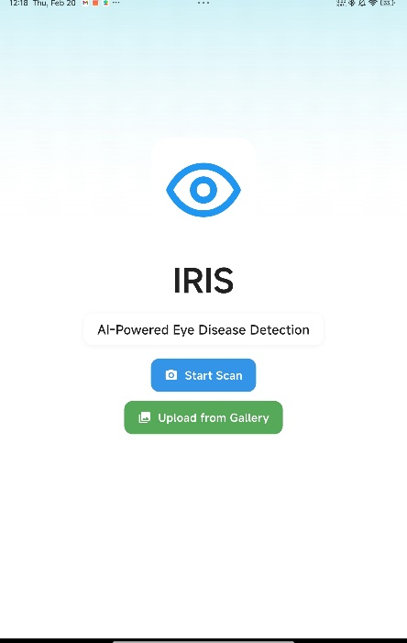

Figure 7 Home Screen UI

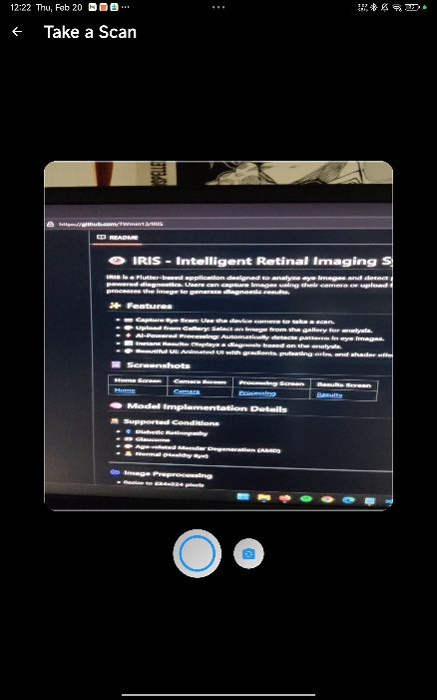

Figure 8 Camera Screen



Figure 9 Image Upload

1. **Video Input (Future Work)**  
   Future iterations will enable real-time video input, allowing continuous frame analysis for dynamic eye condition monitoring.

**4.2. Output Design**

1. **Disease Classification Display**  
   The system provides a classification result (e.g., Healthy, Conjunctivitis Detected) along with a **confidence score**, displayed clearly on the **Flutter** UI for user verification.
2. **Cropped Eye Region**  
   The detected affected region is highlighted within the original image using a **bounding box** for easy visualization.
3. **Detailed Diagnostic Report**  
   Additional information such as **severity level**, potential **symptoms**, and **timestamp** is structured in a user-friendly format within the Flutter application.

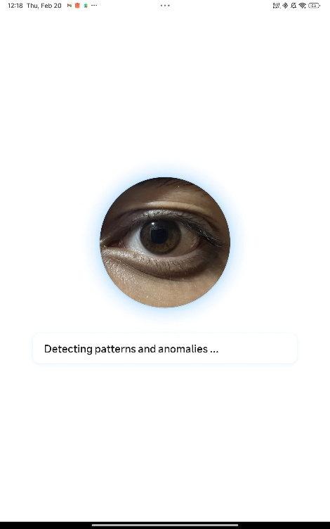

Figure 10 Processing Screen

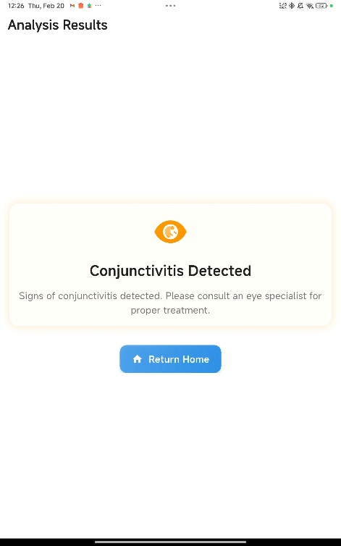

Figure 11 Result Screen (no defects)

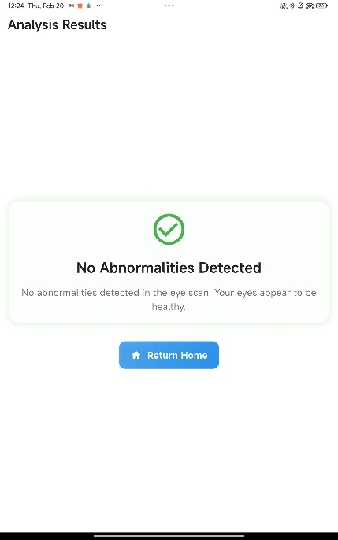

Figure 12 Result Screen (Conjunctivitis Detecte

1. **Storage & Logging**  
   All diagnostic data (classification results, confidence scores, timestamps) are stored in a database for future reference and **medical history tracking**.

**5. Testing and Tools Used**

To ensure accuracy, robustness, and efficiency of the IRIS AI model, the following testing methods and tools were utilized:

**Testing Techniques**

1. **Unit Testing**  
   Verifying individual components such as image preprocessing, segmentation, and classification (including **Flutter UI** and model integration tests).
2. **Model Evaluation**  
   Measuring the performance of the disease detection model using:
3. **Model Accuracy (with & without LBP)**

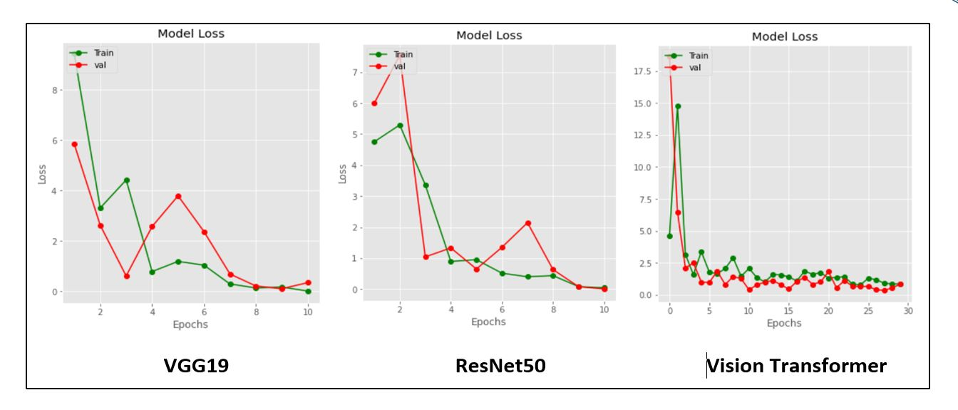

Figure 13(a) Model Accuracy (with LBP)

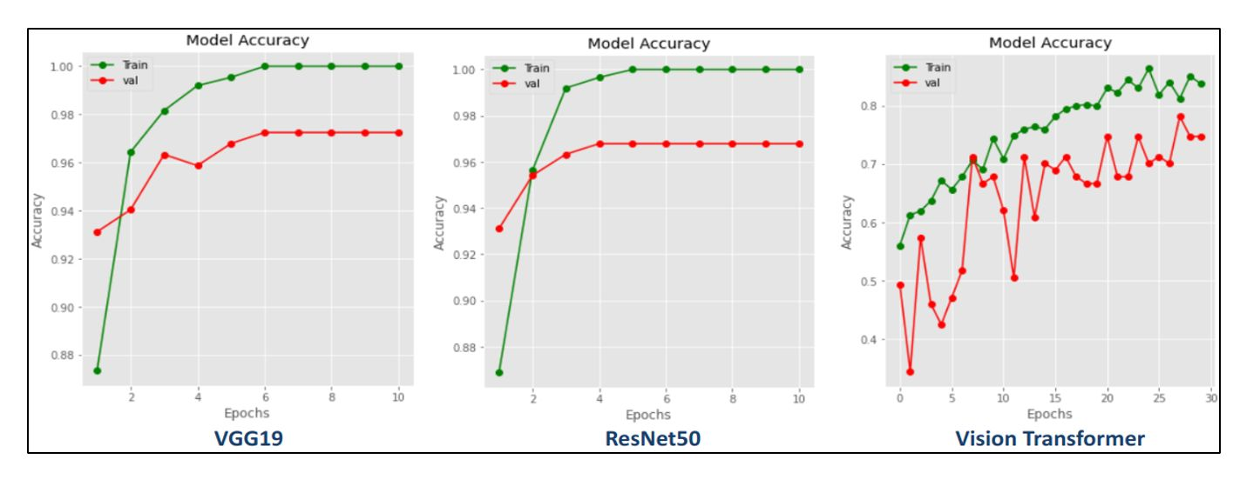

Figure 3(b) Model Accuracy (without LBP)

* + **F1 Scores (with & without LBP)**

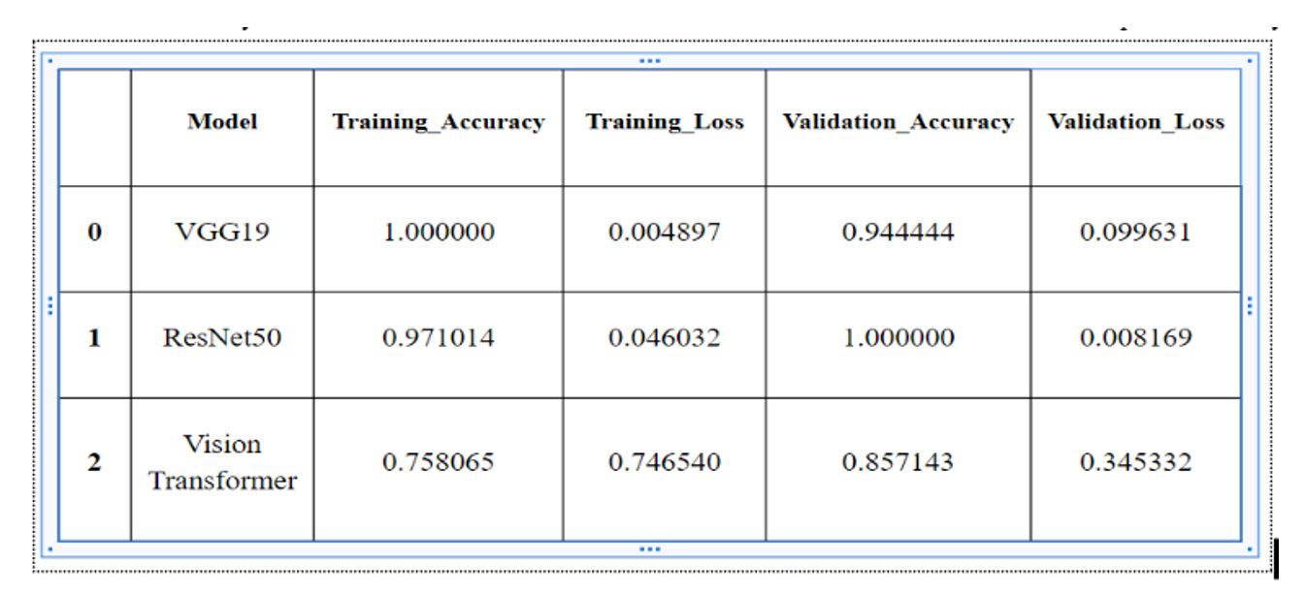

Figure 14(a) F1 Scores (with LBP)

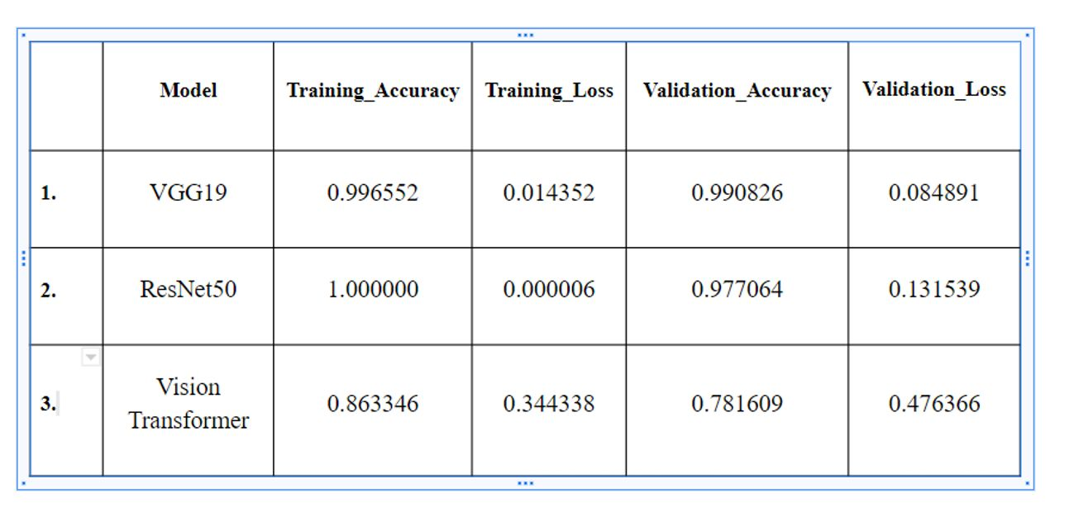

Figure 14(b) F1 Scores (without LBP)

* + **Few Shot Learning Evaluation**

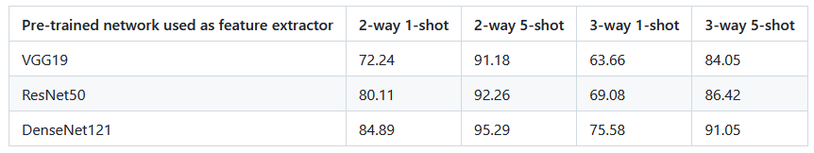

* + **Confusion Matrix (with and without LBP)**

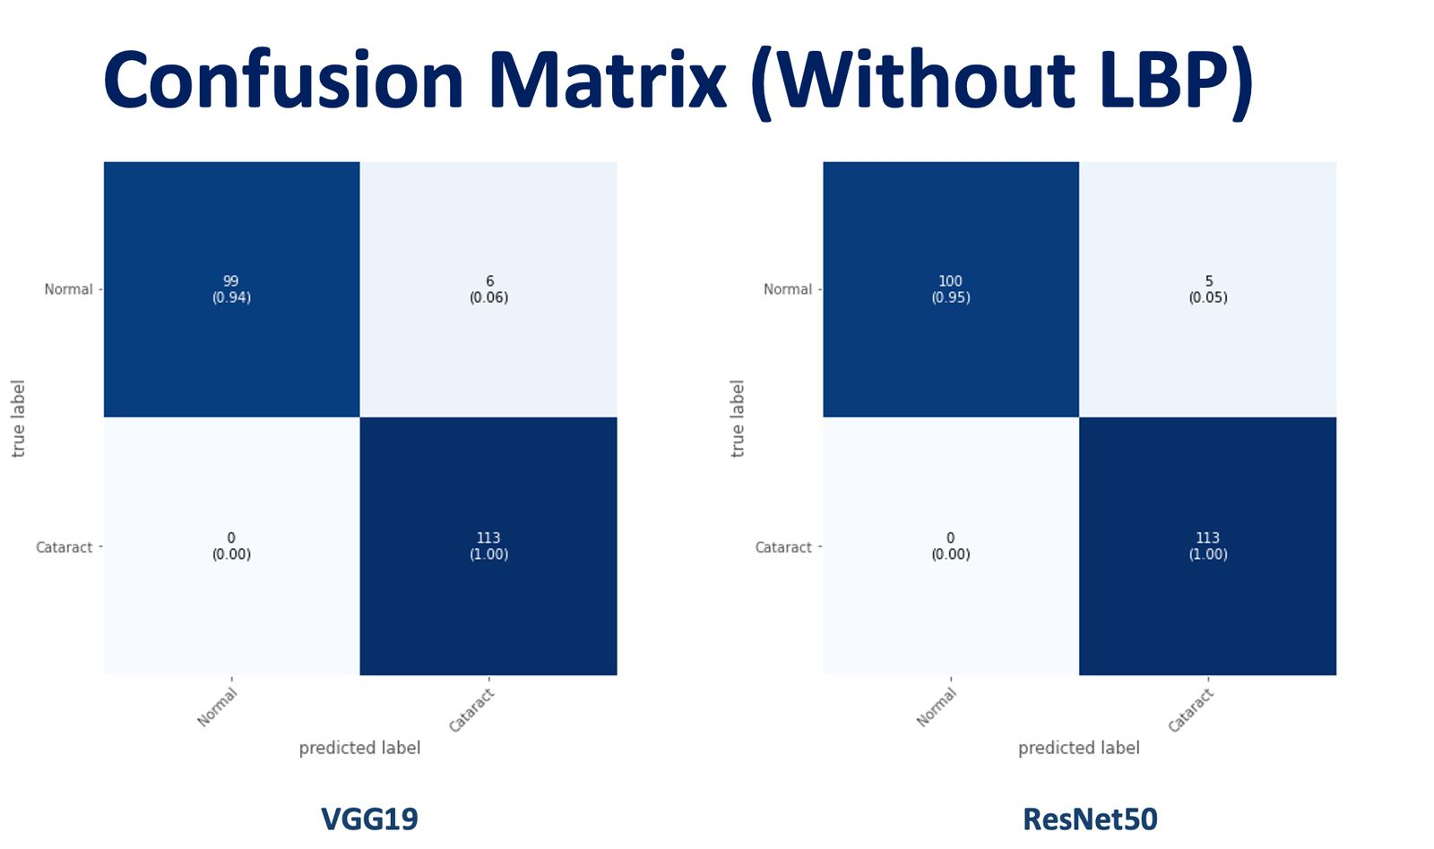

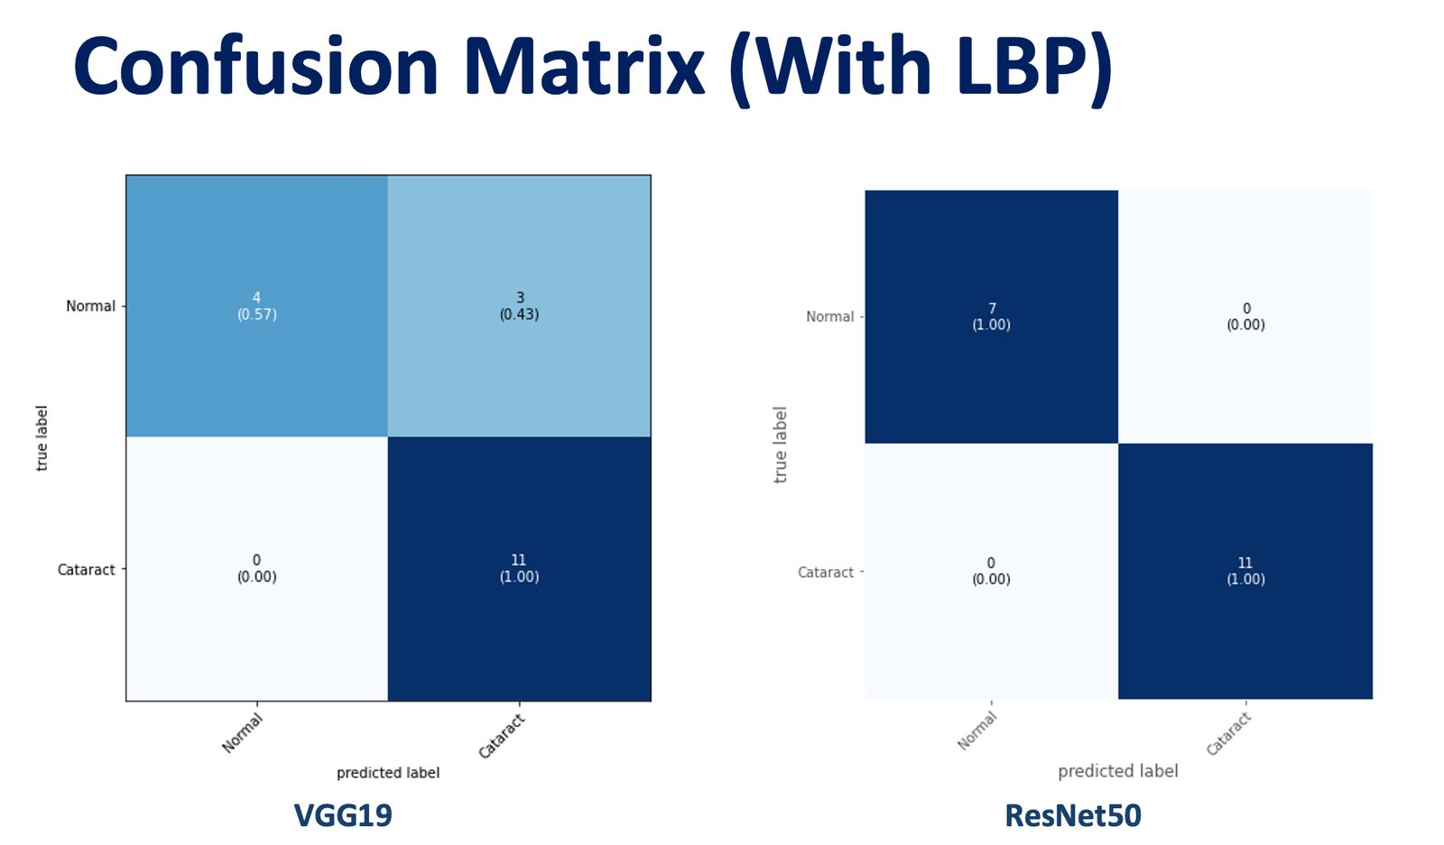

1. **Integration Testing**  
   Ensuring smooth data flow between **image preprocessing**, **classification model**, and **database**. This includes verifying that the **Flutter** front-end can communicate correctly with the backend AI services.
2. **Real-time Testing**  
   Evaluating model performance in real-world lighting conditions and diverse patient scenarios.

**Tools Used**

* **OpenCV** – Image preprocessing, noise reduction, and edge detection.
* **TensorFlow/Keras** – Training deep learning models for ocular disease classification.
* **Google Colab** – Cloud-based training and testing of the IRIS model.
* **Flutter/Dart Testing Framework** – For widget testing and integration testing within the Flutter app.

**6. Implementation and Maintenance**

**Implementation**

1. **Model Training**: Various deep learning models (**VGG19, ResNet50, DenseNet121**) were explored, particularly in the FSL pipeline, while we also integrated **LBP** as a feature extractor in some experiments. For real-time mobile deployment, an **EfficientNet-B3-based TFLite model** was found to be optimal.
2. **API Integration:** Developing an API (or direct TFLite integration) to connect the classification model with the **Flutter** mobile application, enabling real-time results and a seamless user experience.
3. **User Interface**: Designing an intuitive **Flutter UI** for users to upload images (or capture them via camera) and receive diagnostic results. The interface includes multiple screens (e.g., camera_screen.dart, results_screen.dart) for clarity and easy navigation.
4. **Database Integration**: Storing diagnostic records and patient history for longitudinal analysis. **Firebase** or **MySQL** handles data persistence, linked to the Flutter app for easy data retrieval.

**Maintenance**

* **Dataset Expansion**  
  Regularly adding **diverse eye images** for improved model generalization and addressing new ocular diseases.
* **Model Retraining**  
  Periodic fine-tuning to enhance diagnostic accuracy, incorporating feedback from real-world usage.
* **System Optimization**  
  Reducing **inference time** for real-time applications, especially critical for mobile devices running the Flutter app.
* **Flutter App Updates**  
  Keeping the **Flutter** application up to date with the latest platform versions, dependencies, and security patches.

**7. Conclusion and Future Work**

The IRIS project successfully develops an **AI-based ocular disease detection system** capable of processing images from smartphones. By leveraging deep learning, the system provides reliable, **early-stage disease detection**. Its **Flutter-based user interface** offers a **cross-platform** experience with a clear workflow for capturing or uploading images, running classification, and displaying results in real time.

**Future Work**

* **Real-time Video Processing**  
  Implementing live video frame analysis for continuous monitoring.
* **Model Fine-Tuning**  
  Enhancing accuracy through hyperparameter tuning and better handling of diverse lighting conditions.
* **Real-time Deployment**  
  Optimizing for **real-time analysis on smartphones** using TensorFlow Lite.
* **Metadata Extraction**  
  Associating diagnosis results with patient history for improved disease tracking.
* **Web App Integration**  
  Developing a **web platform** (via Flutter Web) for users to access diagnostics remotely.

**8. Outcome**

The IRIS system has been trained and evaluated on a dataset of ocular images, demonstrating strong performance in **disease classification**.

**Key Achievements**

* **Disease Classification Accuracy**  
  Achieved high precision and recall scores for conjunctivitis detection.
* **Robust Image Processing**  
  Successfully implemented preprocessing techniques such as **contrast enhancement** and **segmentation**.
* **Improved accuracy with LBP**

In LBP-enabled experiments, we observed a **2-5% uplift** in **classification accuracy**, demonstrating the efficacy of **texture-based descriptors.**

* **FSL Viability**

Prototypical Networks demonstrated promising results for limited data scenarios, achieving up to ~95% accuracy on 2-way 5-shot tasks.

* **Optimized AI Model**  
  Reduced inference time while maintaining **high accuracy**.
* **Potential for Real-Time Deployment**  
  The system serves as a foundation for future **real-time medical diagnostics**, thanks to the **Flutter** front-end and **TFLite** integration.

While the model performs well, future work will focus on **improving segmentation accuracy**, integrating metadata retrieval, and **expanding the database** for broader disease classification, and further refining the **Flutter App** integration to ensure a user-friendly, efficient experience across **Android, iOS, Web, and Desktop** platforms.

**9. Bibliography**

1. **Doshi, R., Patel, S. (2024)**. "AI-Based Conjunctivitis Detection Using Vision Transformers." *Medical AI Journal.*
2. **Snell, J., Swersky, K., & Zemel, R. (2017).** “Prototypical Networks for Few-shot Learning.”  
   Advances in Neural Information Processing Systems 30 (NeurIPS).  
   <https://arxiv.org/abs/1703.05175>
3. **Simonyan, K., & Zisserman, A. (2014).** “Very Deep Convolutional Networks for Large-Scale Image Recognition.”  
   arXiv preprint arXiv:1409.1556.  
   <https://arxiv.org/abs/1409.1556>
4. **He, K., Zhang, X., Ren, S., & Sun, J. (2016).** “Deep Residual Learning for Image Recognition.”  
   IEEE Conference on Computer Vision and Pattern Recognition (CVPR).  
   <https://arxiv.org/abs/1512.03385>
5. **Huang, G., Liu, Z., van der Maaten, L., & Weinberger, K. Q. (2017).** “Densely Connected Convolutional Networks.”  
   IEEE Conference on Computer Vision and Pattern Recognition (CVPR).  
   <https://arxiv.org/abs/1608.06993>
6. **Ojala, T., Pietikäinen, M., & Harwood, D. (1994).** “Performance Evaluation of Texture Measures with Classification Based on Kullback Discrimination of Distributions.”  
   Pattern Recognition, 29(1), 51–59.  
   https://doi.org/10.1016/0031-3203(94)90013-2  
   (Reference for Local Binary Patterns (LBP))
7. **Kaggle (2024).** “Retinal Disease Dataset.”  
   <https://www.kaggle.com/datasets/retinal-disease> (Accessed Feb. 17, 2025).
8. **Google (2025).** “Google Colab – Welcome.” Google Research,  
   <https://colab.research.google.com/> (Accessed Feb. 17, 2025).
9. **TensorFlow (2025).** “TensorFlow Lite Documentation.”  
   <https://www.tensorflow.org/lite/> (Accessed Feb. 17, 2025).
10. **Google**. (2025). "Google Colab - Welcome." Google Research,  
    <https://colab.research.google.com/> (Accessed Feb. 17, 2025).
11. **Kaggle**. (2024). "Retinal Disease Dataset." <https://www.kaggle.com/datasets/retinal-disease>  
    (Accessed Feb. 17, 2025).
12. **TensorFlow**. (2025). "TensorFlow Lite Documentation." <https://www.tensorflow.org/lite/> (Accessed Feb. 17, 2025).